**Creating a Simple Chatbot using a Traditional Approach**

Sally Shahin

University of the cmberlands

This report outlines the process of developing a simple chatbot utilizing the Microsoft Bot Framework, focusing on both the implementation and testing phases. The primary aim was to establish a foundational chatbot that echoes user inputs, providing a basis for future enhancements. Key aspects of the project include environment setup, application development, and troubleshooting connectivity issues during testing.

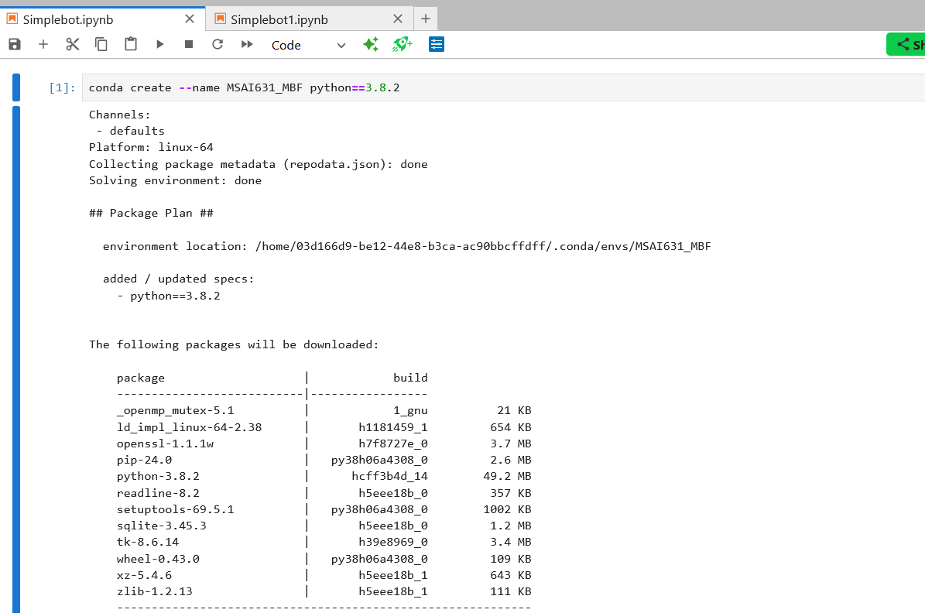

Chatbots are increasingly critical in digital communication, offering scalable interactions between businesses and customers (McTear, Callejas, & Griol, 2016). This project explores the development of such a tool using the Microsoft Bot Framework and Python, tested within a local environment using the Bot Framework Emulator.

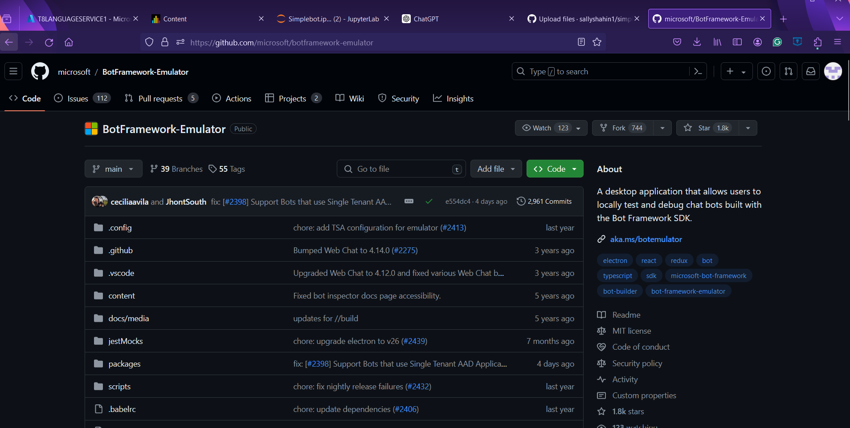

An Anaconda environment was established specifically for this project to manage dependencies efficiently (Anaconda, Inc., 2017). The required libraries, including aiohttp, were installed to support the chatbot’s operations (Microsoft, n.d.).

The EchoBot sample from Microsoft's repository was utilized as a starting point, programmed to replicate user messages, providing a basic level of interaction (Microsoft, n.d.).

The chatbot was successfully launched and initially tested, confirming its functionality to echo inputs correctly. This testing was conducted locally using the Bot Framework Emulator (Microsoft, n.d.).

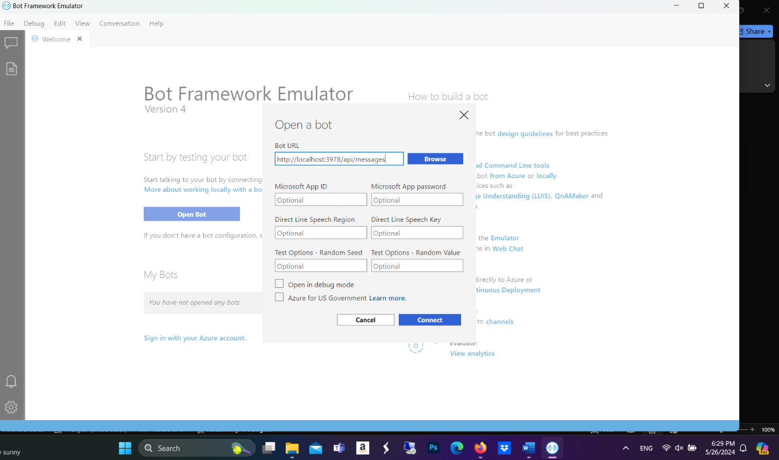

During further testing, connectivity issues were noted, evidenced by POST 400 errors indicating failed message transmissions to the chatbot:

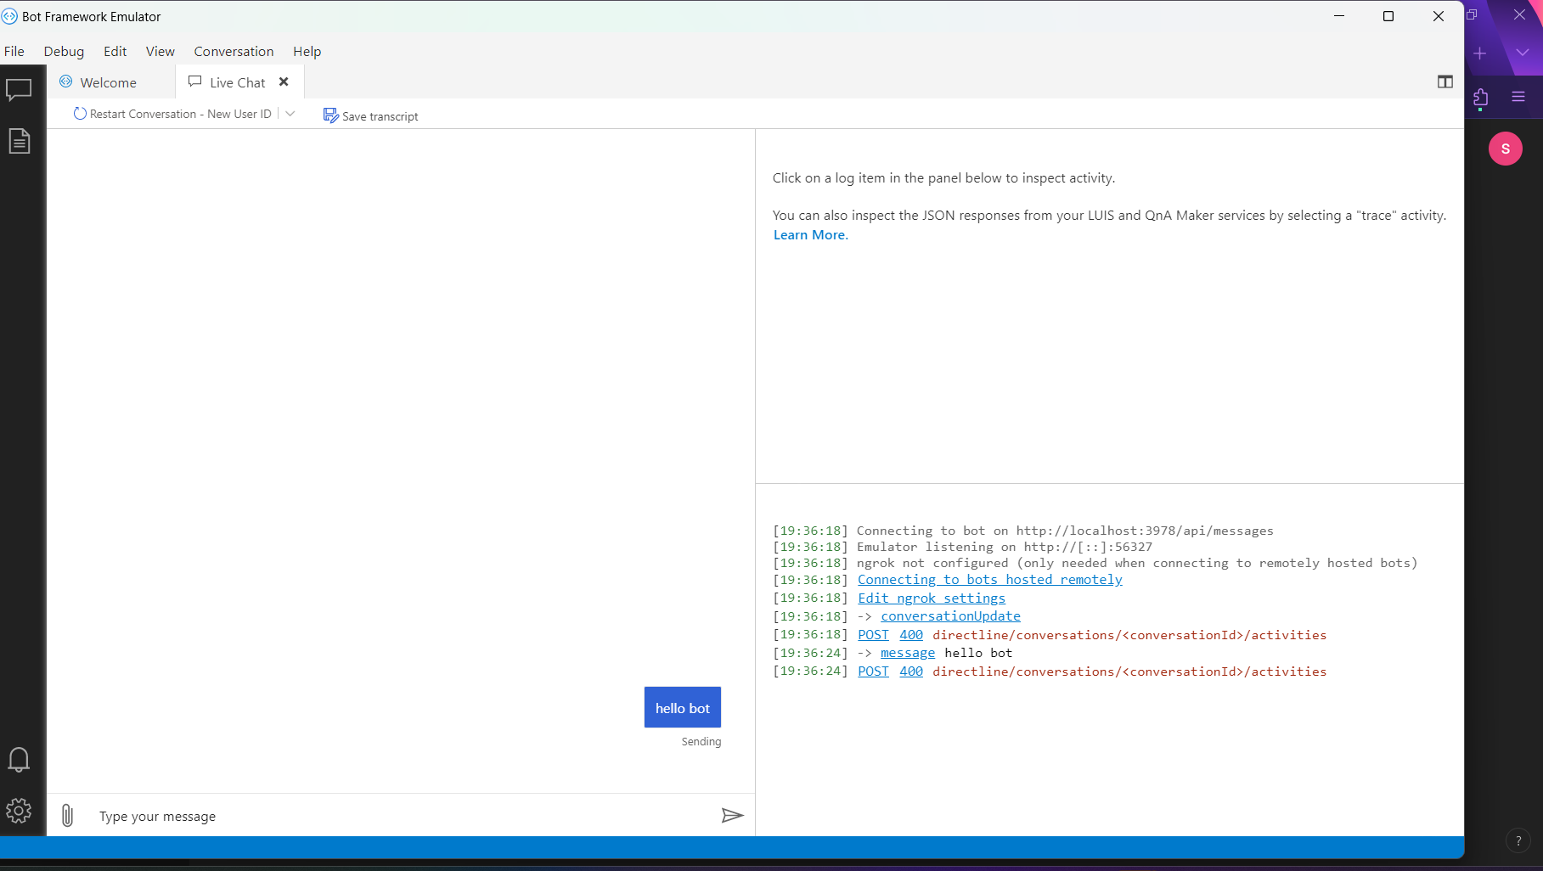

The POST 400 errors suggest bad requests within the conversation flow, potentially due to misconfiguration or endpoint issues in the API handling (Microsoft, n.d.).

Strategies to resolve these issues included reviewing the bot’s configuration files and consulting Microsoft’s documentation to address common issues related to these errors (Microsoft, n.d.).

This project demonstrated the feasibility of developing a basic chatbot using traditional methodologies and highlighted the importance of thorough testing and configuration. Despite the challenges, such as the encountered POST 400 errors, the project provided valuable insights into bot development workflows and potential troubleshooting strategies (McTear et al., 2016).

All files got uploaded o github under simplebot <https://github.com/sallyshahin1/simplechatbot/>

Sources:

Anaconda, I. (2017). *Managing environments*. https://conda.io/projects/conda/en/latest/userguide/tasks/manage-environments.html

Microsoft. (n.d.). *Microsoft Bot Framework*. <https://dev.botframework.com/>

McTear, M., Callejas, Z., & Griol, D. (2016). *The conversational interface: Talking to smart devices*. Springer.